Sensitivity and initial validation Information for MicroLYSIS-RNA

Introduction:
MicroLYSIS RNA is a lysis buffer that can work with the following three sample types and take samples through a rapid lysis method and then directly in to RT-qPCR.

- Dry Swabs
- Viral Transport Medium
- Sputum / saliva

Diagnosis of Sars-Cov-2 (COVID-19) antigen is hampered by numerous pinch points. These include availability of extraction reagents, plasticware, high end liquid handling systems, and finances depending on where in the world testing is taking place. There is a need to overcome some if not all of these pinch points. Here we demonstrate the viability of going straight to RT-qPCR post lysis using MicroLYSIS-RNA from Microzone that retains a high level of sensitivity while being simple, easy and considerably cheaper than magnetic bead extraction.

Using the MicroLYSIS RNA it is possible to go straight from a simple lysis procedure directly to RT-qPCR.

Method:
The protocol is short and simple. Take 100µl of viral transport medium and add 100µl of MicroLYSIS-RNA, vortex briefly. Incubate at room temperature for 5 minutes. Heat the sample to 95C for 10 minutes (this can be in a regular thermocycler if using PCR strips or a heating block). Cool. Add the resulting lysate to the RT-qPCR reaction. We used the Co-Diagnostics Logix Smart COVID-19 RT-qPCR kit. We added 5µl of the lysis supernatant to 5µl of the RT-qPCR reagent. We then followed the Co-Diagnostics’ instructions for amplification: Reverse Transcriptase 15 minutes at 45⁰C followed by one incubation at 95⁰C for 2 minutes, followed by 50 cycles of 95⁰C for 3 seconds and 55⁰C for 32 seconds. We used the MIC thermocycler from BMS that was labelled as Co-Dx Box form Co-Diagnostics. The MIC is a small, rapid, 48 position qPCR thermocycler.

Samples: We used the Vircel Amplirun Total Sars-Cov-2 Control that was rehydrated and then diluted with Virocult® viral transport medium from MWE to form different levels of copy numbers.

Sensitivity Testing:

To test the sensitivity of the process we rehydrated the Amplirun total Sars-Cov-2 Control from Vircel (Spain) in viral transport media from MWE call Virocult®. We then diluted again with the Virocult® to produce viral quantities of 21.8 copies/µl, 10.9 copies/µl, 5.74 copies/µl, 2.73 copies/µl. At this point we used MicroLYSIS RNA to lyse the virus and then went directly to RT-qPCR using the Co-Diagnostics Logix Smart COVID-19 kit. Figure 1 shows the results.

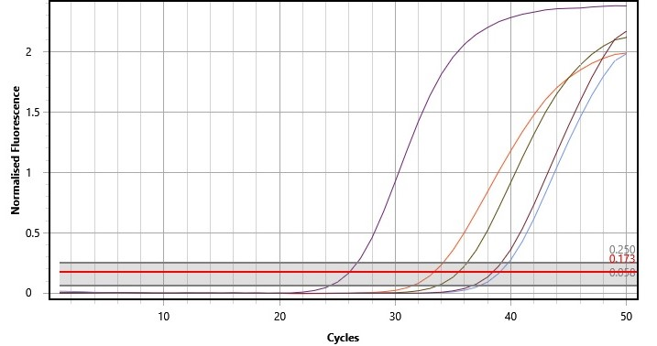
Samples: 21.8, 10.9, 5.74 & 2.73 copies/µl
Positive control
Figure 1
We were able to consistently pick up samples with a median of 2.73 copies/µl (the product from Vircel is delivered with a range of virus per ml).

We also diluted the post lysis samples in molecular grrade water to see the effect on the assay. We saw increased efficiency in the RT-qPCR and only a small decrease in the Ct levels. With the very low level sample of 2.73 copies/µl we did see dropout in dilutions above 1:4. Data not shown.

Validation Trial:

We have results from one small fully independent rapid trial that demonstrated a 87.5% concordance with results from their magnetic bead extracted RNA. In this trial we did not have a chance to discuss the findings nor to help create a testing process with regard to dilution of samples and to see if this increased or decreased the concordance. They used a different transport medium and RT-qPCR kit to the ones we used for sensitivity testing. We therefore believe that this trial with their unknown viral transport medium and their RT-qPCR was a very interesting and successful first trial.

Discussion:

We were able to reliably and consistently detect the lowest dilution level that we had created of a median of 2.73 copies/µl. The Ct values were in the mid to late thirties. Using the Co-Diagnostic Logix Smart COVID-19 kit allowed us to run the kit for 50 cycles. Co-Diagnostics use of CoPrimers eliminates the production of primer dimers and the false positives they can produce. The results were very clear and not at all ambiguous. This can be seen in figure one. The efficiencies of the RT-qPCR increased as we further diluted the samples.

Clinical outcomes vs Ct values: We are aware that the lysis Ct levels are not as high as those using extracted RNA from the same sample. This is to be expected. However, when we look at clinical outcomes, we believe that there is strong concordance between the two methods.

Saliva: We have tested MicroLYSIS RNA with saliva using the Co-Diagnostics’ kit. This worked well and we got strong amplification. The Co-Diagnostic kit has been validated for use with Saliva in the USA. We are doing more work with saliva samples.

Dry Swabs: We have tested dry swabs and again got very strong robust amplification using a modified method to the one outline above. In this instance we have only tested with DNA. However, having amplified viral RNA in other sample types, we are confident in the ability for MicroLYSIS RNA to work well with these sample types and viral RNA.

Conclusion:

MicroLYSIS RNA is a sensitive, rapid, easy to use, low cost method for COVID-19 detection when using viral transport medium and going direct to RT-qPCR post lysis.

The three reagents we used for sensitivity testing were the MicroLysis RNA, MWE Virocult®, the Co-Diagnostics Logix-Smart COVID-19 RT-qPCR kit. We used the Amplirun Total Sars-CoV-2 Control from Vircel as our sample.

We believe that MicroLYSIS RNA offers a sensitive alternative to RNA extraction. It has the capacity to elevate pinch points of obtaining RNA extraction kits and also an excellent option in resource poor areas around the world.

Further validation and testing may be required if using different viral transport medium and RT-qPCR kits.

Reagents Used:

- Microzone, Stourbridge, UK – MicroLYSIS RNA. A strong lysis buffer that leaves the sample ready for direct use in RT-qPCR. Supplied by Clent Life Science Ltd.
- Co-Diagnsotics, Salt Lake City, USA: Logix Smart COVID-19 RT-qPCR Detection Kit (CE-IVD and FDA-EUA approved).
- MWE, Corsham UK – Sigma Virocult® – viral transport medium. (www.mwe.co.uk)
- Vircel, Spain: Amplirun Total Sars-Cov-2 Control

